Clean marker
- Bullish example
- Only scan for bullish candles after the potential marker
- Find a bullish candle that Is high is higher then the bullish candle on the left and right of it.
- High is taken
- Find the low of the lowest candle after the straight candle (includes the straight candle)
- Check distance and if OB is mitigated
- plot zone
straight candle is the middle candle when scanning for the 3 candle pattern. It is the tallest candle with the high being higher then the 2 candles on the left and right of it
this whole sequence should have no bearish candles. If there is one it will it should be classed as break marker and those criteria must be met

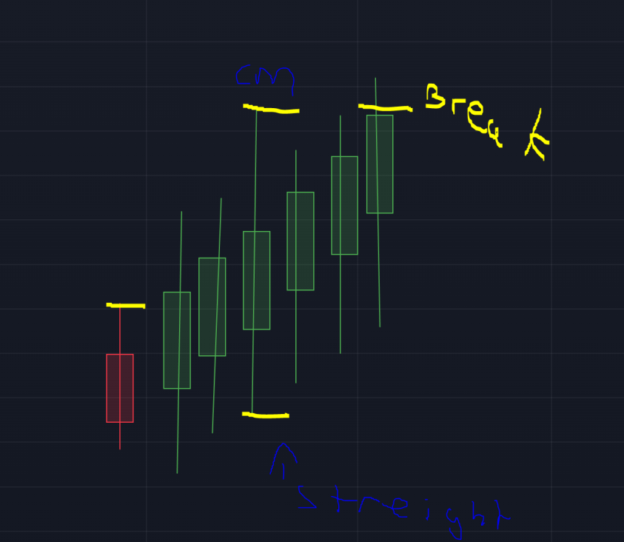
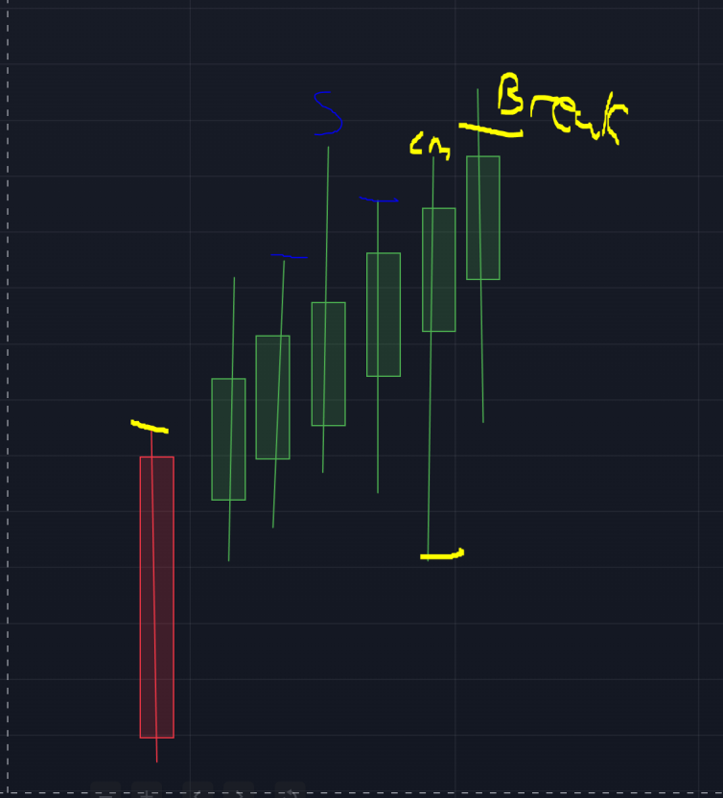
S= straight candle
Cm= clean marker candle

Break marker
- scan for bearish candle
- You find bearish candle or multiple after the OB
- A bullish candle closes crosses the high of either the high of the bearish candles or the bullish candle before the bearish candles started = valid signal

For this you may need to only look at closed candles only as knowing if it is a bullish or bearish candle is important

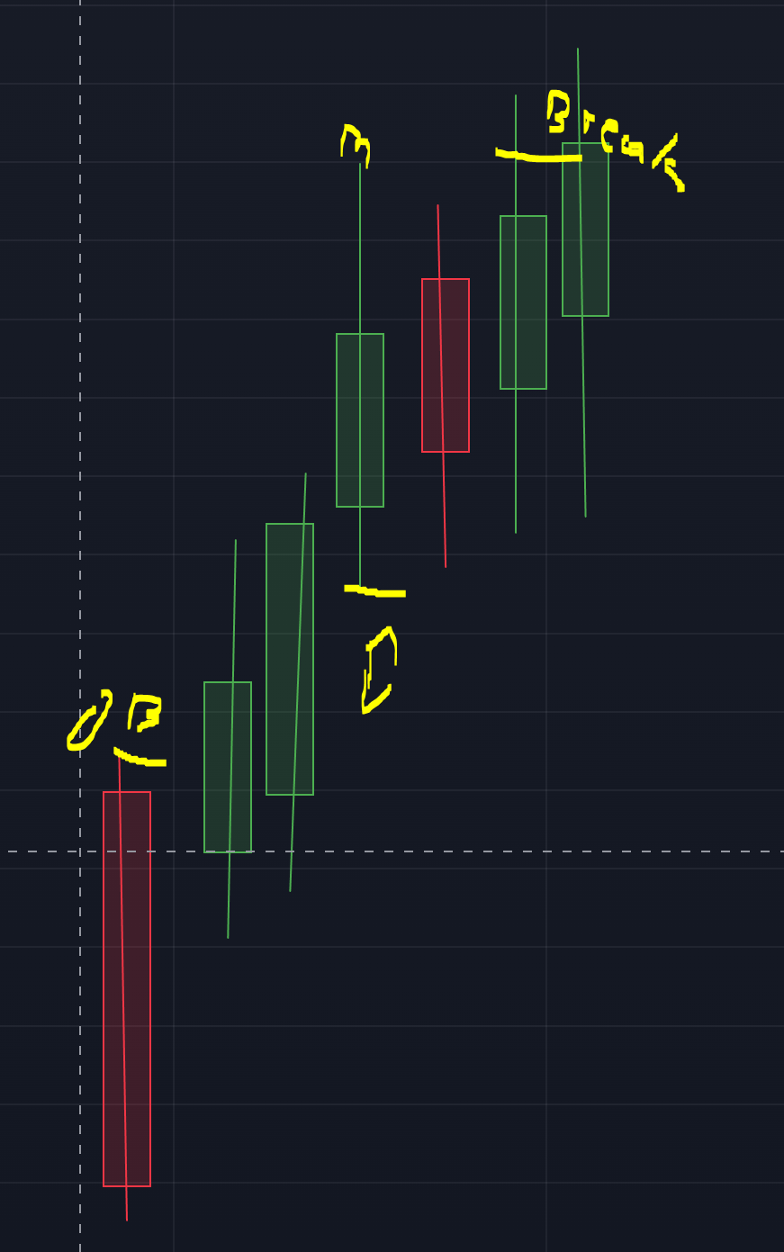
Bulish candle closes and has moved above the high created by the bullish candle high that is before the bearish candle
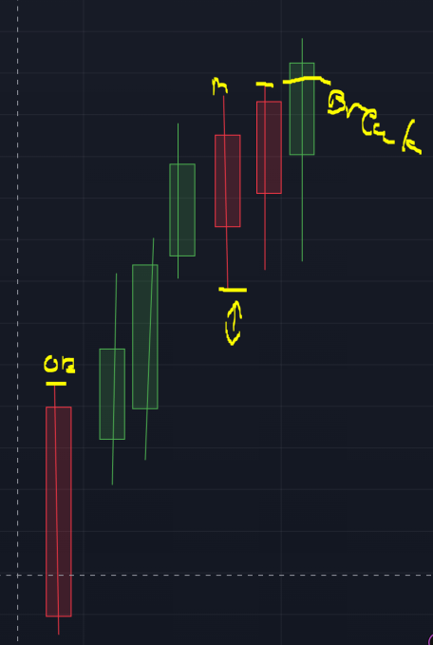 highest candle of the bearish candle and the bullish candle before the bearish candle has been taken.
The lowest low of those candles is the marker
Check distance/ if the OB is mitigated

Multiple markers
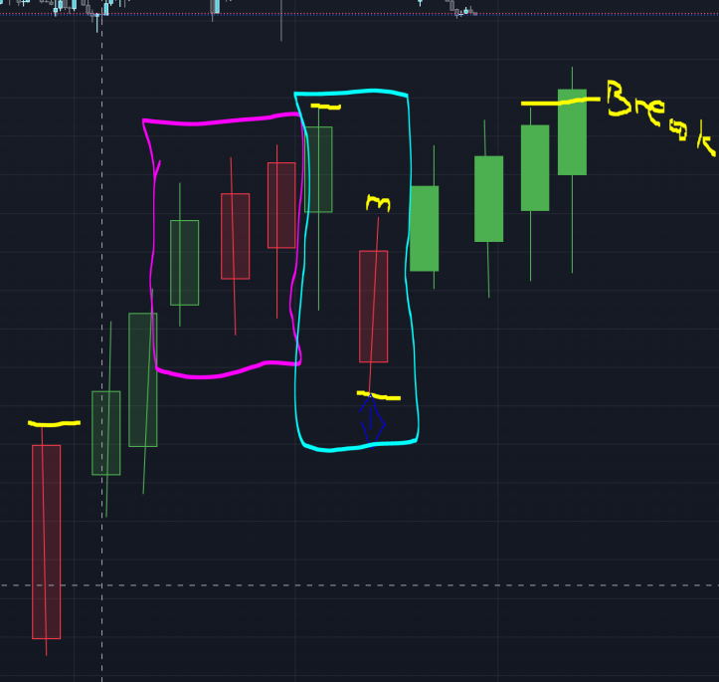
Even though there is multiple bearish candles broken up by bullish candles.
The same rules still apply.
If the first marker has valid distance there is no reason to keep searching
If it is not in valid distance then wait for next clean marker or break marker

